HIPAA Notice of Privacy Practices

THIS NOTICE DESCRIBES HOW MEDICAL INFORMATION ABOUT YOU MAY BE USED AND DISCLOSED AND HOW
YOU CAN GET ACCESS TO THIS INFORMATION. PLEASE REVIEW IT CAREFULLY.

OUR PLEDGE REGARDING MEDICAL INFORMATION
The privacy of your medical information is important to us. We understand that your medical information is personal and we are committed to protecting it. We create a record of the care and services at our organization. We need this record to provide you with quality care and to comply with certain legal requirements. This notice will tell you about the ways we may use and share medical information about you. We also describe your rights and certain duties we have regarding the use and disclosure of medical information.

OUR LEGAL DUTY
Law Requires Us to:
1. Keep medical information private; follow the term of the notice that is now in effect.
- Give you this notice describing out legal duties, privacy practices, and your rights regarding your medical information.
We Have the Right to:
- Change our privacy practices and the terms of this notice at any time, provided that law permits the changes.
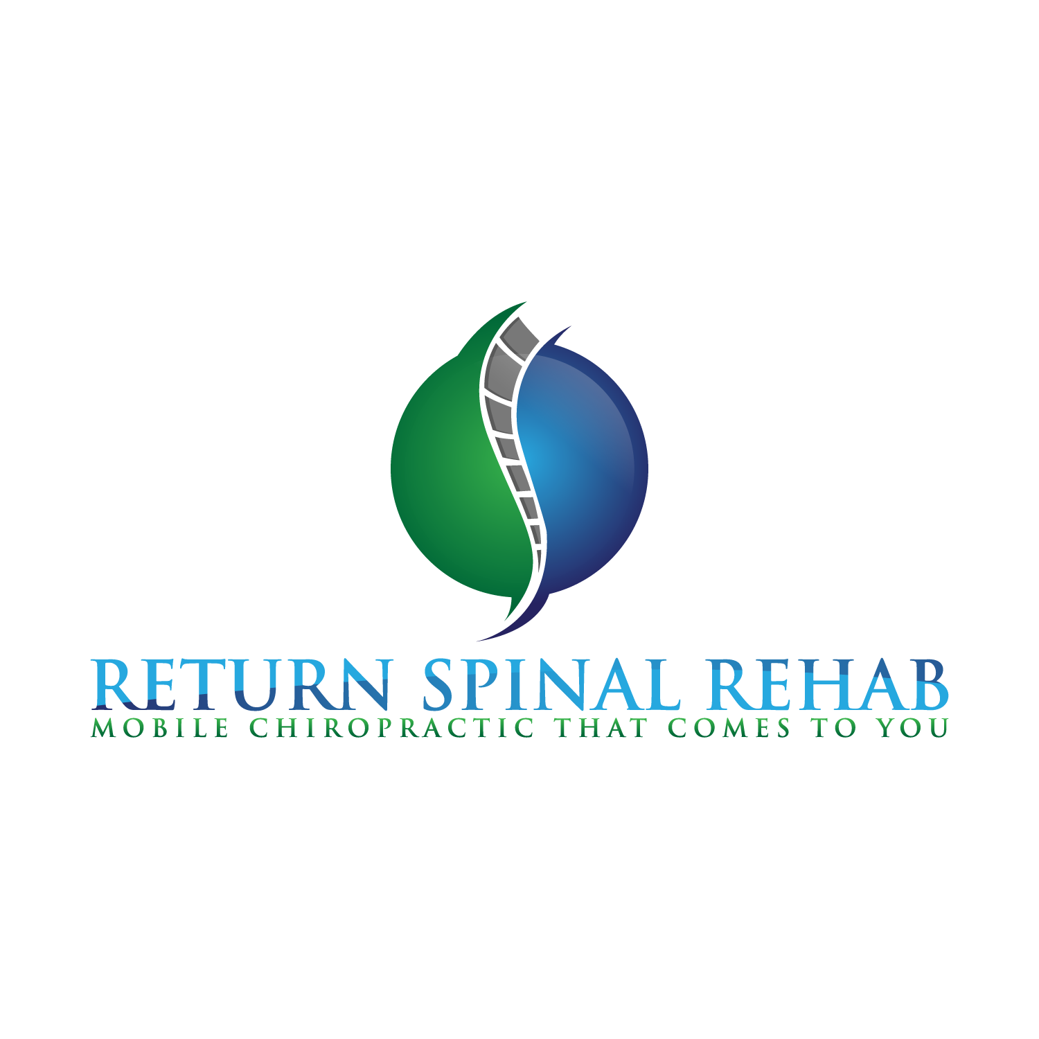
- Make the changes in out privacy practices and the new terms of out notices affective for all medical information that we keep, including information previously created or received before the changes.

Notice of change to Privacy Practices:
- Before we make an important change in our privacy practices, we will change this notice and make the new notice available upon request.

USES AND DISCLOSURE OF YOUR MEDICAL INFORMATION
The following section describes different ways we use and disclose information. For each kind of use or disclosure, we will explain what we mean and give an example. Not every use of disclosure will be listed. However, we have listed all of the different ways we are permitted to use and disclose medical information.
We will not use or disclose your medical information for any purpose not listed below without your profile written authority. Any specific written authorization you provide may be revoked at any time by writing to us.

FOR TREATMENT
We may use medical information about you to provide you with medical treatment or services. We may disclose medical information about you to doctors, nurses, technicians, or other people who are taking care of you. WE may also share medical information about you to other health care providers to assist in treating you.

FOR PAYMENT
We may use and disclose your medical information for payment purposes.

Notice of Privacy Practices (cont.)

FOR HEALTH CARE OPERATIONS
We may use and disclose your medical information for out health care operations. This might include measuring and improving quality, evaluating the performance of employees, conducting training programs, and getting the accreditation, certificates, licenses and credentials we need to serve you.

Notifications: Medical information to notify or help notify
- A family member
- Your personal representative
- Another person responsible for your care

Court Orders, Judicial Administrative Proceedings, Law Enforcement

We may disclose medical information in response to a court administrative order, subpoena, discovery request, or other lawful process, as well as law enforcement officials under certain circumstances. We may share limited information with law enforcement officials concerning the medical information of a request, fugitive, material witness, crime victims or missing person. We may share the medical information of an inmate or other person in lawful custody with a law enforcement official or correctional institution for the reporting of certain types of wounds.

Victims of Abuse, Neglect or Domestic Violence

We may disclose medical information to appropriate authorities if we reasonably believe that you are a possible victim of abuse, neglect or domestic violence, or the possible victim of other crimes.

YOUR INDIVIDUAL RIGHTS
You have a right to:
1. Review or get copies of your medical information. You may request that we provide copies in a format other than photocopies. We will use the format you request unless it is not practical for us to do so. You may get the form to request access by using the contract information listed at the end of this notice. You may request access by sending a letter to the contact person listed at the end of this notice, (If you request copies, we will charge $.50 for each page and postage if you want copies mailed to you.)
- Request that we communicate with you about your medical information by different means or to different locations. Your request that we communicate your medical information to you by different means or at different locations must be made in writing to the contact person listed at the end of this notice.

QUESTIONS AND COMPLAINTS
IF YOU HAVE ANY QUESTIONS ABOUT THIS NOTICE, PLEASE CONTACT:
Dr. Meghan McHan, D.C.
drmchan@dallasmobilechiro.com
(972) 854-2022
If you think that we may have violated your privacy rights, contact the person named above.
You may also submit a written complaint to the U.S. Department of Health and Human Services.
We will provide you with the address to file your complaint with the U.S. Department of Health and Human Services.
We will not retaliate in any way if you choose to file a complaint.
I have received the notice of Privacy Practices and I have been provided an opportunity to review it.
Name:_____________________________________
Signature:__________________________________
Date:______________________________________

